**Assignment 1: Basics of MATLAB**

**1. Array Operations**

**i) Create a matrix and perform basic operations**

% Create a matrix

A = [1 2 3; 4 5 6; 7 8 9];

B = [9 8 7; 6 5 4; 3 2 1];

% Addition

C_add = A + B;

% Subtraction

C_sub = A - B;

% Multiplication (element-wise)

C_mul = A .* B;

% Division (element-wise)

C_div = A ./ B;

% Display results

disp('Addition:'); disp(C_add);

disp('Subtraction:'); disp(C_sub);

disp('Multiplication:'); disp(C_mul);

disp('Division:'); disp(C_div);

**2. Decision Control Statements**

**i) Determine whether a number is positive, negative, or zero**

number = input('Enter a number: ');

if number > 0

disp('The number is positive');

elseif number < 0

disp('The number is negative');

else

disp('The number is zero');

end

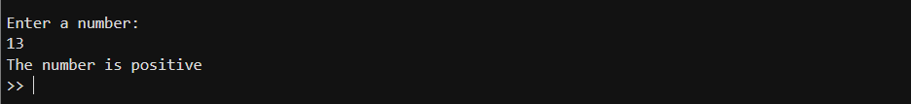

**3. For Loop Basics**

**i) Print numbers from 1 to 10**

matlab

Copy

for i = 1:10

disp(i);

end



**ii) Calculate the sum of numbers from 1 to 100**

sum_val = 0;

for i = 1:100

sum_val = sum_val + i;

end

disp(['Sum is: ', num2str(sum_val)]);

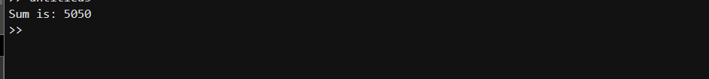

**For Loop with Arrays**

**i) Find the maximum value in an array**

array = [5, 3, 9, 1, 6];

max_val = array(1);

for i = 2:length(array)

if array(i) > max_val

max_val = array(i);

end

end

disp(['Maximum value is: ', num2str(max_val)]);



**While Loop Basics**

**i) Print numbers from 1 to 10**

i = 1;

while i <= 10

disp(i);

i = i + 1;

end



**ii) Calculate the factorial of a number**

num = input('Enter a number: ');

factorial = 1;

i = 1;

while i <= num

factorial = factorial * i;

i = i + 1;

end

disp(['Factorial is: ', num2str(factorial)]);

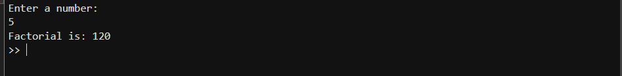

**4. String Operations**

**i) Concatenate two or more strings**

str1 = 'Hello';

str2 = 'World';

result = [str1, ' ', str2];

disp(result);

**output - Hello World**

ii) Calculate the length of a string

str = 'Hello World';

len = length(str);

disp(['Length of the string is: ', num2str(len)]);

**output - Length of the string is: 11**

**iii) Extract specific characters from a string**

str = 'Hello World';

extracted = str(1:5);

disp(['Extracted characters are: ', extracted]);

**output - Extracted characters are: Hello**

**5. Basic Function**

**i) Simple function that takes two inputs and returns their sum**

function sum_val = add(a, b)

sum_val = a + b;

end

**ii) Call the function from a script and display the result**

result = add(5, 10);

disp(['Sum is: ', num2str(result)]);

**output - 15**

**iii) Function that takes three inputs and returns their sum**

function sum_val = add_three(a, b, c)

sum_val = a + b + c;

end

**iv) Function that takes one input and returns two outputs**

function [double_val, triple_val] = multiply(input)

double_val = input * 2;

triple_val = input * 3;

end

**6. Plotting a Graph**

**i) Generate sinusoidal signal and plot it**

x = linspace(0, 2*pi, 100);

y = sin(x);

figure;

plot(x, y);

title('Sinusoidal Signal');

xlabel('x');

ylabel('sin(x)');

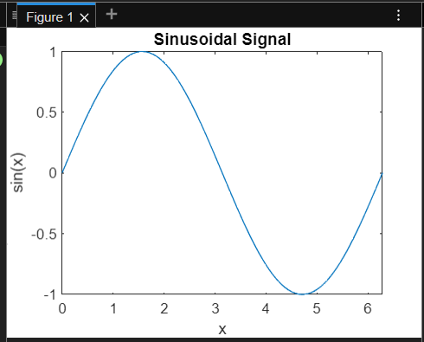

**ii) Generate sinusoidal cosine signal with three different amplitudes**

x = linspace(0, 2*pi, 100);

y1 = cos(x);

y2 = 2 * cos(x);

y3 = 3 * cos(x);

% a) Multiple plots on the same graph

figure;

plot(x, y1, x, y2, x, y3);

title('Cosine Signals with Different Amplitudes');

xlabel('x');

ylabel('cos(x)');

legend('Amplitude 1', 'Amplitude 2', 'Amplitude 3');

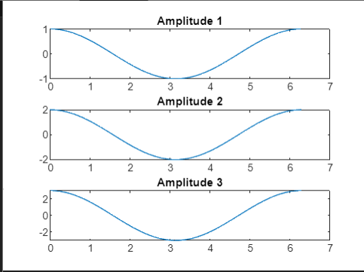

% b) Multiple plots within a single figure window

figure;

subplot(3, 1, 1);

plot(x, y1);

title('Amplitude 1');

subplot(3, 1, 2);

plot(x, y2);

title('Amplitude 2');

subplot(3, 1, 3);

plot(x, y3);

title('Amplitude 3');

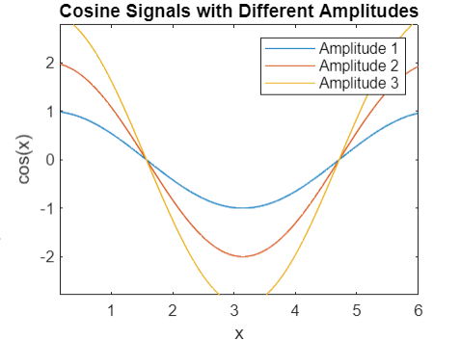

**7. Determine whether a given year is a leap year**

year = input('Enter a year: ');

if mod(year, 4) == 0

if mod(year, 100) == 0

if mod(year, 400) == 0

disp('Leap Year');

else

disp('Not a Leap Year');

end

else

disp('Leap Year');

end

else

disp('Not a Leap Year');

end



**8. Solve system of linear equations using MATLAB**

A = [1 2; 3 4; 7 8];

B = [5; 6; 9];

X = A \ B;

x1 = X(1);

x2 = X(2);

disp(['x1: ', num2str(x1), ', x2: ', num2str(x2)]);

**9. Find integers between 1 and 10000 divisible by 37**

divisible_by_37 = find(mod(1:10000, 37) == 0);

disp(divisible_by_37);

**10. Guess My Number game**

target = randi(10);

guess = input('Guess a number between 1 and 10: ');

if guess == target

disp('Congratulations! You guessed the number.');

else

disp('Better luck next time.');

end

**11. Threshold device temperature check**

threshold = 5;

room_temp = input('Enter the room temperature: ');

if room_temp > threshold

disp(['Temperature is above threshold by ', num2str(room_temp - threshold), ' degrees']);

elseif room_temp < threshold

disp(['Temperature is below threshold by ', num2str(threshold - room_temp), ' degrees']);

else

disp('Temperature is at the threshold');

end